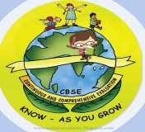
GREENWOOD PUBLIC SCHOOL, D.D. NAGAR
HOLIDAY HOMEWORK SESSION – 2020-21
CLASS – VI

SUBJECT - COMPUTER
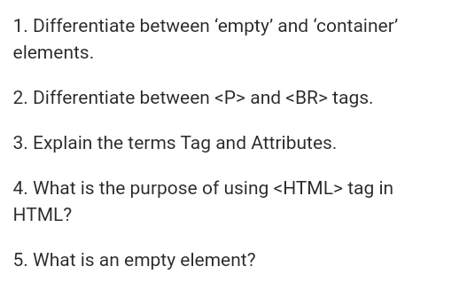

SUBJECT - MATHEMATICS
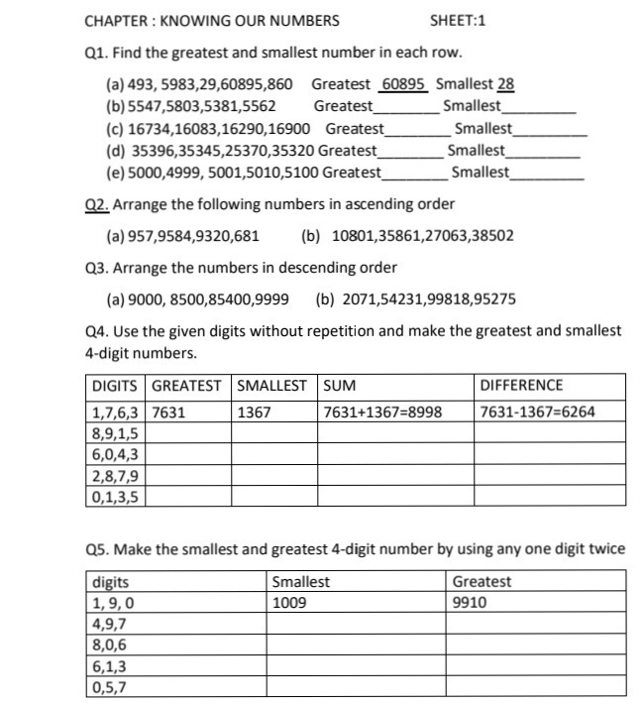

SUBJECT – S. ST.
Q-1. Learn full exercise of chapter 1 & 2.
Q-2. Learn full question and answer of chapter 1 & 2
Q-3. Write the history of your family
Q-4. Write 10 ancient writers name with their books
Q-5. If possible visit one historical place and write your experience.
Q-6. Fill one physical map of India with colour.

SUBJECT – ENGLISH
- Learn Chapter 1& 2 (New Pathways)
- Write Paragraph on
- Importance of a healthy lifestyle
Or
- My motto in Life
- Learn the definition of following term: -
- Sentence
- Noun
- Pronoun
- Verb
- Adverb
- Adjective
- Write a letter to your friend congratulating him /her on passing the class 6 examinations.
You are shikha/Saurabh.
- You are abhinaya living at Vaishali Nagar, Jaipur. Write a letter to the S.H.O complaining about the law & order situation in your area.
SUBJECT – SCIENCE
- Topic – I
Water cycle with diagram and explain
Topic – II
Rain water harvesting explain with diagram
Topic – III
Earthworm structure
Topic – IV
Circuit diagram of torch with explaination
Topic – V
Draw or paste different type of fibers and explain them.
SUBJECT – SANSKRIT
iz- 1 laLd`r esa if{k;ksa ds uke] i'kqvks ds uke] QYkksa ds uke o lfCt;ksa ds uke fp= lfgr fyf[k,A
iz- 2 nSfud thou esa mi;ksx esa vkus okyh oLrqvksa ds uke laLd`r esa fyf[k,A
iz- 3 1 ls 10 rd laLd`r esa fxurh fy[kdj mUgs daBLFk dhft,A
iz- 4 bUVjusV dh lgk;rk ls xhrk ds 'yksd fy[kdj mUgs dBaLFk djksA

SUBJECT – HINDI
iz- 1 eqU'kh izsepUnz dh dksbZ 5 dgkfu;ksa ds uke fyf[k,A
iz- 2 Hkkjr dh 5 izeq[k ufn;ksa dk o.kZu djrs gq, mUgs lkQ lqFkjk j[kus gsrq vius lq>ko Hkh fyf[k,A
iz- 3 vuqPNsn fy[ksa ¼1½ ty gh thou gSA ¼2½ [ksyksa dk gekjs thou esa egRoA
iz- 4 vius fo|ky; ds izk/kkukpk;Z th dks vodk'k ekaxus gsrq chekjh dk izkFkZuk i= fyf[k,A ¼5 ckj½
iz- 5 izfrfnu 1 ist lqUnj lqys[k fyf[k,A
uksV %& lHkh dk;Z A4 'khV ij djsaA

